# **Free recall**

# **Introduction**

This experiment is inspired by Ebbinghaus’ research on human memory function (Radvansky & Ashcraft, 2014), and aims to demonstrate some relevant findings presented in research using free recall tasks, e.g. primacy and recency effects (Radvansky & Ashcraft, 2014).

Primacy effects comprise greater probability of recall for early items in a list since these are supposedly rehearsed more, and thus likely transferred to long-term memory (Radvansky & Ashcraft, 2014). Thus, primacy effects are expected to be found in all list conditions.

Recency effects comprise greater probability of recall for later items since these are expected to fall within capacity and time span of short-term memory (Radvansky & Ashcraft, 2014). Thus, recency effects are expected to be found within the data. However, an interference list condition should display no recency effect, as the interference task is expected to block rehearsal.

Primacy and recency effects may be effectively explained by rehearsal components of Atkinson and Shiffrin’s multi-store model or Baddeley’s model of working memory (Radvansky & Ashcraft, 2014).

As opposed to Ebbinghaus’, this experiment was conducted with actual words, rather than nonsense words, to test for any concreteness effect (Fiebach & Friederici, 2003). Allan Paivio’s dual-coding hypothesis suggests that probability of recall should be higher for concrete words than for abstract words (Radvansky & Ashcraft, 2014, p. 191). The data is expected to support this concreteness effect, which may also be explained by the context availability model (Fiebach & Friederici, 2003).

# **Method**

This experiment included *N* = 86 participants, all psychology students at UCPH. Age and sex differences were not considered.

## **Materials**

* Nine word lists (concrete or abstract, one interference list)

## **Test procedure**

The experiment included nine word lists (concrete or abstract) of 20 items each.

Prior to the experiment, the participant (P) was instructed by the experimenter (E). All lists were processed consecutively. E read aloud the words with an interval of about two seconds between each item, and a one minute break between each list. Following each list, P was asked to recall all words they remembered. An observer noted response words.

For the interference list, P was asked to count backwards by three from 392 for 30 seconds before recall.

# **Results**

All statistical results were obtained using SPSS.

## **Word position and list condition significantly influenced probability of recall**

Figure 1 displays probability of recall according to word position in all three lists.

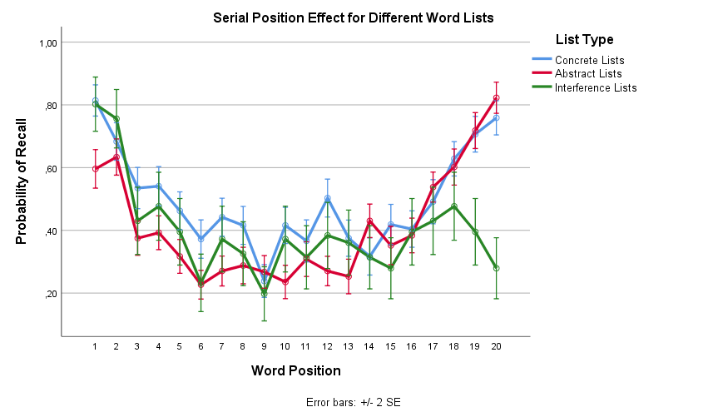

Figure 1: Probability of recall according to word position and list condition for entire sample.

Figure 1 provides initial indication of primacy and recency effects in the data, shown by the U-shape of the graphs. The interference list graph does not follow this U-shape, indicating a lack of recency effect. Further, it appears that recall was generally better for concrete than for abstract words; if such a difference is significant, it would support the presence of a concreteness effect.

A repeated measures ANOVA showed significant main effects of list type, *F*(1.69, 143.86) = 25.23, *p* < .001, $η_{p}^{2}$ = .23 (Huyhn-Feldt corrected), and word position, *F*(16.05, 1364.42) = 50.23, *p* < .001, $η_{p}^{2}$ = .37 (Huyhn-Feldt corrected) on probability of recall, and a significant interaction between these, *F*(28.24, 2400.28) = 7.82, *p* < .001, $η_{p}^{2}$ = .08 (Huyhn-Feldt corrected).

The interaction shows how influence of word position varied depending on list condition, likely reflecting differences in recall for last words across conditions (Figure 1). The main effects confirm that probability of recall varied significantly according to both list condition and word position. However, to test whether the main effect of list condition supports the presence of a concreteness effect, the test must be conducted without the interference list condition.

## **A concreteness effect was present in the data**

A repeated measures ANOVA was conducted to test if probability of recall was significantly influenced by list condition when considering only abstract and concrete words conditions.

The test showed a significant main effect of list type, *F*(1, 85) = 52.67, *p* < .001, $η_{p}^{2}$ = .38. Results thus support the presence of a concreteness effect (Figure 1).

Further, a repeated measures ANOVA showed a significant main effect of list type on probability of recall for the first two words in lists, *F*(1.65, 140.49) = 13.05, *p* < .001, $η_{p}^{2}$ = .13. This suggests that probability of recall varies according to the concreteness of words independently of serial position (Figure 1, Table 1), suggesting a concreteness effect may exist in long-term memory independently of any primacy or recency effects.

## **Primacy and recency effects were observed in the data**

Table 1 displays descriptive statistics for first, middle, and last words for each list condition, and further suggests the presence of primacy effects in all lists, and recency effects in all but interference list. Further, differences in probability of recall between first and last words between concrete and abstract lists are noteworthy.

|  |  |  |  |  |  |  |  |  |
| --- | --- | --- | --- | --- | --- | --- | --- | --- |
| Table 1 *Average probability of recall for each word list type for select word positions.* | | | | | | | | |
|  | First Two Words | |  | Middle Four Words | |  | Last Two Words | |
| Word list | *M* | *SD* |  | *M* | *SD* |  | *M* | *SD* |
| Concrete Lists | 0.75 | (0.22) |  | 0.38 | (0.20) |  | 0.73 | (0.22) |
| Abstract Lists | 0.61 | (0.23) |  | 0.27 | (0.17) |  | 0.77 | (0.23) |
| Interference Lists | 0.78 | (0.33) |  | 0.32 | (0.30) |  | 0.34 | (0.40) |
| *Note*. Recall is shown as mean probability | | | | |  |  |  |  |

Paired samples *t*-tests showed significant differences in mean recall probability between first two (*M* = 0.75, *SD* = 0.22) and middle four words of concrete lists (*M* = 0.38, *SD* = 0.20), *t*(85) = 15.53, *p* < .001, *d* = 1.75, between first two (*M* = 0.61, *SD* = 0.23) and middle four words of abstract lists (*M* = 0.27, *SD* = 0.17), *t*(85) = 14.57, *p* < .001, *d* = 1.74, and between first two (*M* = 0.78, *SD* = 0.33) and middle four words of interference lists (*M* = 0.32, *SD* = 0.30), *t*(85) = 9.94, *p* < .001, *d* = 1.47.

This provides evidence for a primacy effect for all three conditions, as expected.

Paired samples *t*-tests showed significant differences in mean recall probability between last two (*M* = 0.73, *SD* = 0.22) and middle four words of concrete lists, *t*(85) = 11.12, *p* < .001, *d* = 1.65, between last two (*M* = 0.77, *SD* = 0.23) and middle four words of abstract lists, *t*(85) = 18.35, *p* < .001, *d* = 2.55, but no significant difference between last two (*M* = 0.34, *SD* = 0.40) and middle four words of interference lists, *t*(85) = 0.41, *p* = .68, *d* = 0.06.

This provides evidence for a recency effect for concrete and abstract conditions, but no recency effect for interference list conditions, as expected.

Figure 2 shows that primacy, recency and concreteness effects may also be observed at an individual level, however, these effects are less clear, and looking at individual data thus provides a more muddy image, perhaps reflecting specific mnemonics applied (Radvansky & Ashcraft, 2014).

Figure 2: Probability of recall according to word position and list condition for FP19225.

# **Conclusion**

Our findings provide evidence for primacy, recency, and concreteness effects.

# **Literature**

Fiebach, C. J., & Friederici, A. D. (2004). Processing concrete words: fMRI evidence against a

specific right-hemisphere involvement. *Neuropsychologia*, *42*(1), 62-70.

Radvansky, G. A. & Ashcraft, M. H. (2014). *Cognition*(6. udg.). Pearson Education.